3.

a)

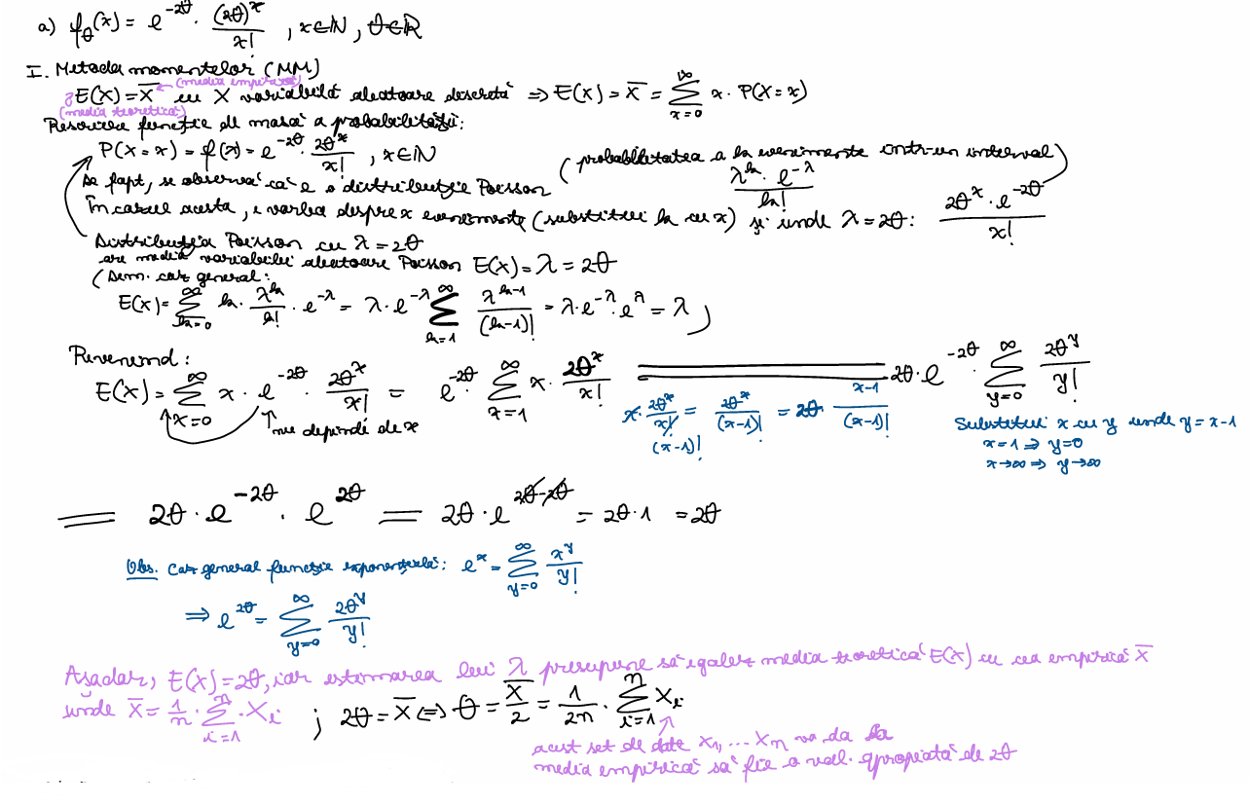

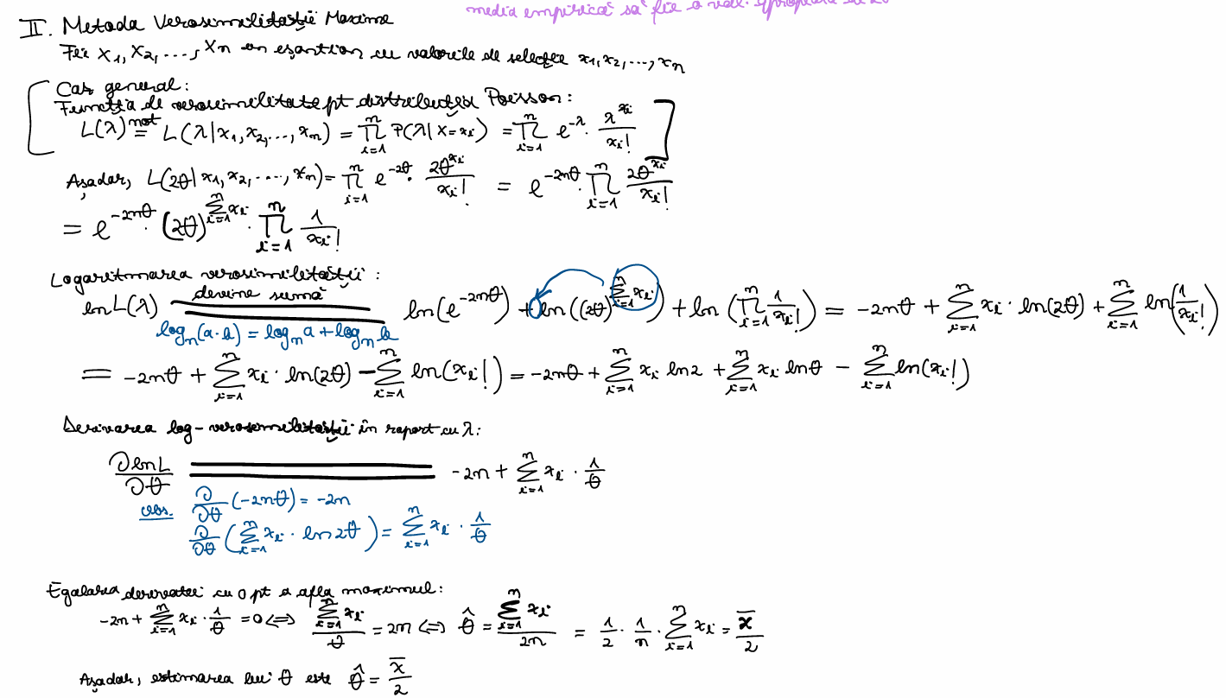

## a) f(teta)(x) = e^(-2*teta)*((2*teta)^x/x!), x nr natural, teta nr real

# esantionul care e de fapt un vector numeric (c combina valorile intr-un vector)

date_esantion <- c(8, 12, 6, 14, 9, 12, 15, 7, 15, 7, 10, 10, 14, 9, 12, 15, 11, 6, 8, 6, 8, 8, 9, 12, 13, 10, 11, 11, 13, 15, 10, 8, 7, 8, 13, 9, 9, 13, 12, 9, 10, 6, 10, 8, 10, 11, 12, 11, 9, 10, 7, 8, 8, 16, 7, 15, 10, 10, 8, 14, 13, 4, 11, 13, 6, 9, 13, 10, 10, 12, 11, 5, 6, 4, 9, 6, 9, 7, 13, 9, 11, 5, 5, 9, 15, 10, 11, 10, 14, 7, 11, 9, 14, 10, 5, 10, 8, 12, 13, 11)

## MM

x_bar <- mean(date_esantion) # media 1/n*(suma dupa i de la 1 la n din)xi

teta_estimat <- x_bar/2 # formula determinata pentru functie folosind MM

## MVM

sum_x <- sum(date_esantion)

sum_log_factorial <- sum(lfactorial(date_esantion))

logVerosimilitate <- function(teta)

{

log_verosim <- (-2)*length(date_esantion)*teta+log(2)*sum_x+log(teta)*sum_x-sum_log_factorial

return(log_verosim)

}

t <- seq(0.001, 0.5, by = 0.0001)

plot(t, sapply(t, logVerosimilitate), type = "l", col = "blue")

rez <- optimize(logVerosimilitate, interval = c(0.001,100), maximum = TRUE)

teta_mvm <- rez$maximum

cat("Estimarea lui teta folosind metoda momentelor:", teta_estimat,"\n")

cat("Estimarea lui teta folosind metoda verosimilitatii maxime:", teta_mvm,"\n")

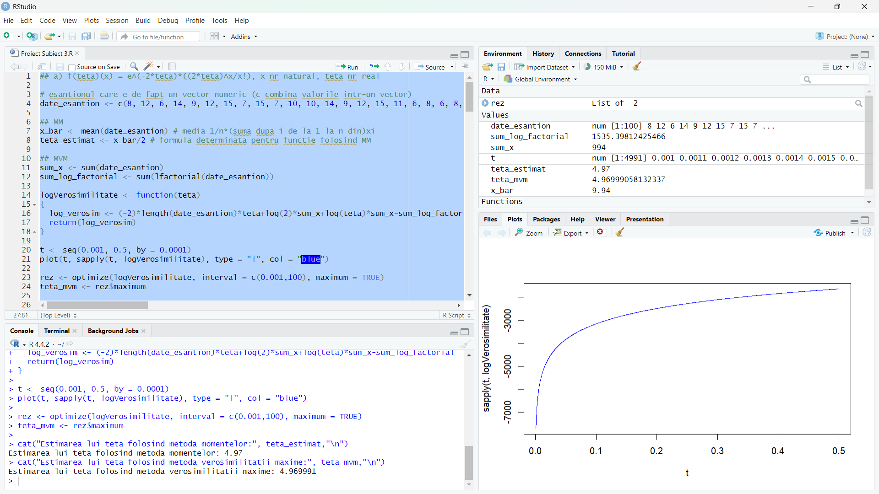

b)

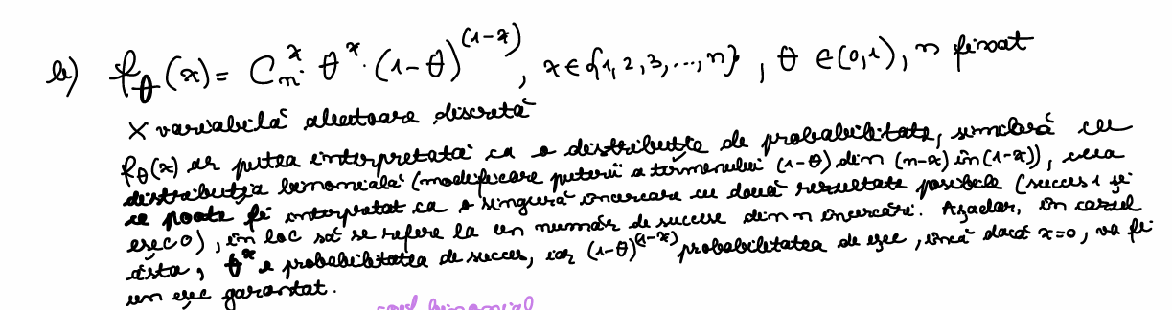

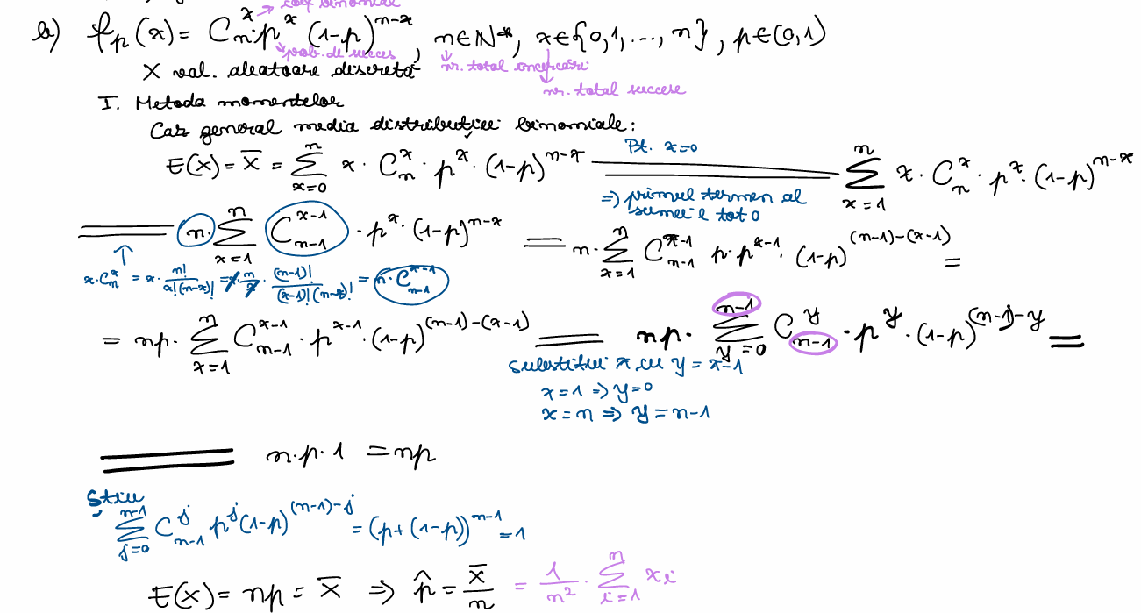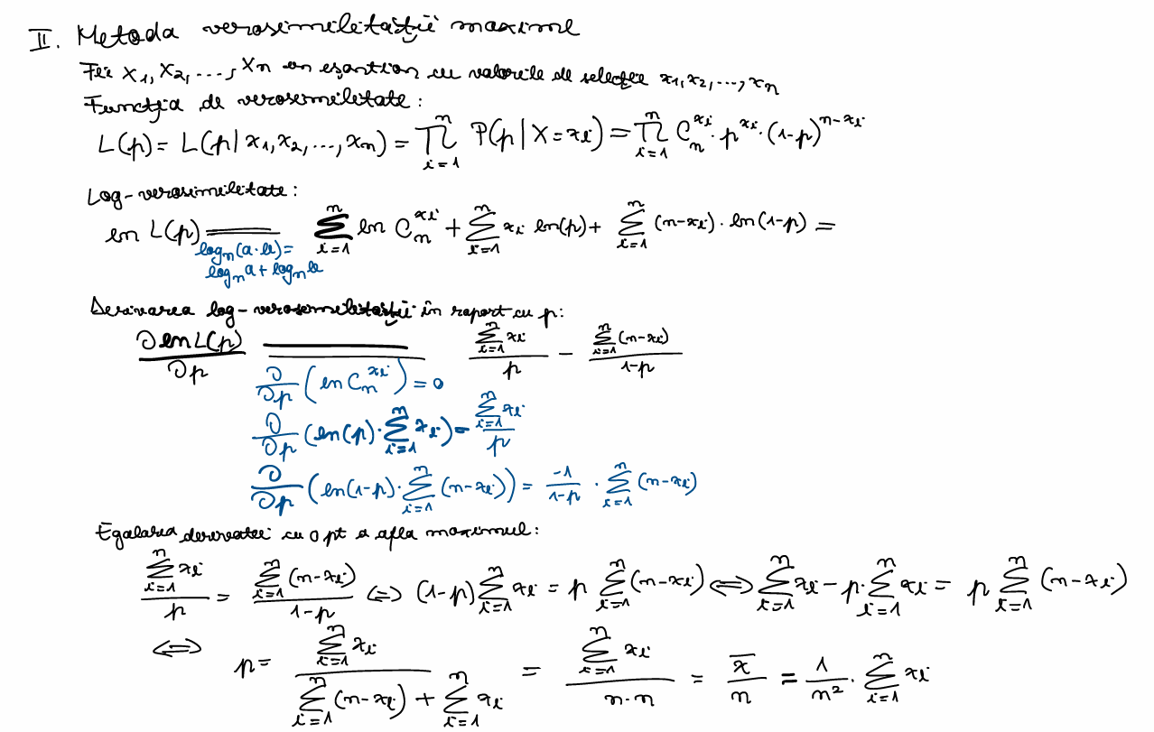

## b) f(teta)(x) = (combinari de n luate cate x)*teta^x*(1-teta)^(n-x), x apartine 1,2,3,...,n, teta apartine (0,1), n fixat

# esantionul care e de fapt un vector numeric (c combina valorile intr-un vector)

date_esantion <- c(3, 2, 1, 4, 2, 3, 4, 1, 3, 2, 2, 4, 2, 1, 7, 5, 4, 5, 5, 2, 3, 4, 3, 1, 2, 4, 1, 1, 2, 3, 1, 3, 1, 4, 1, 3, 1, 6, 1, 3, 3, 4, 3, 1, 3, 2, 2, 3, 2, 4,

1, 1, 2, 6, 3, 1, 3, 6, 1, 2, 3, 6, 3, 2, 2, 2, 4, 2, 1, 3, 3, 4, 2, 3, 4, 1, 4, 4, 6, 3, 3, 5, 2, 2, 2, 3, 1, 3, 1, 3, 3, 5, 3, 4, 3, 2, 4, 2, 3, 3)

n <- 14

## MM

x_bar <- mean(date_esantion) # media 1/n*(suma dupa i de la 1 la n din)xi

teta_estimat <- x_bar/n # formula determinata pentru functie folosind MM

## MVM

sum_x <- sum(date_esantion)

sum_n_minus_x <- sum(n-date_esantion)

sum_log_combinari <- sum(log(choose(n,date_esantion)))

logVerosimilitate <- function(teta)

{

log_verosim <- sum_log_combinari+log(teta)*sum_x+log(1-teta)*sum_n_minus_x

return(log_verosim)

}

t <- seq(0.001, 0.999, by = 0.001)

plot(t, sapply(t, logVerosimilitate), type = "l", col = "blue")

rez <- optimize(logVerosimilitate, interval = c(0.001,0.999), maximum = TRUE)

teta_mvm <- rez$maximum

cat("Estimarea lui teta folosind metoda momentelor:", teta_estimat,"\n")

cat("Estimarea lui teta folosind metoda verosimilitatii maxime:", teta_mvm,"\n")

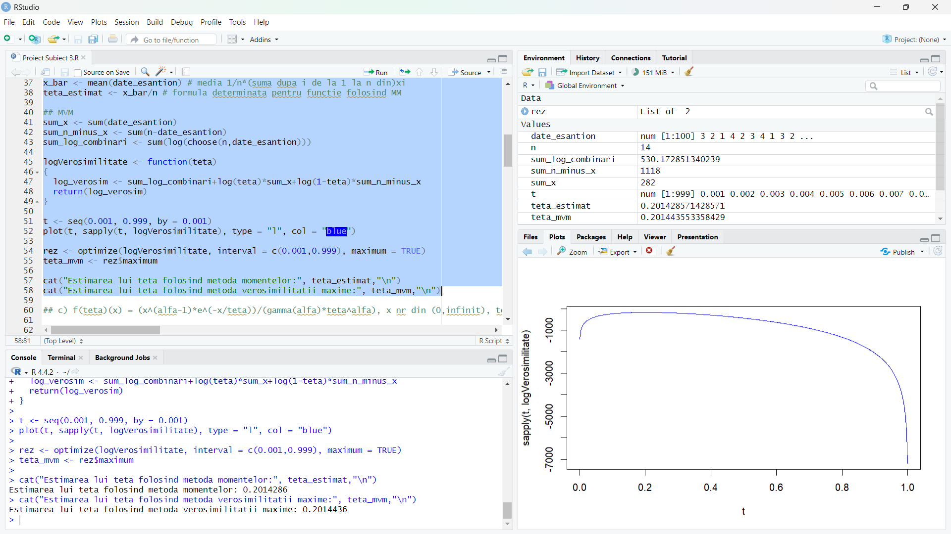

c)

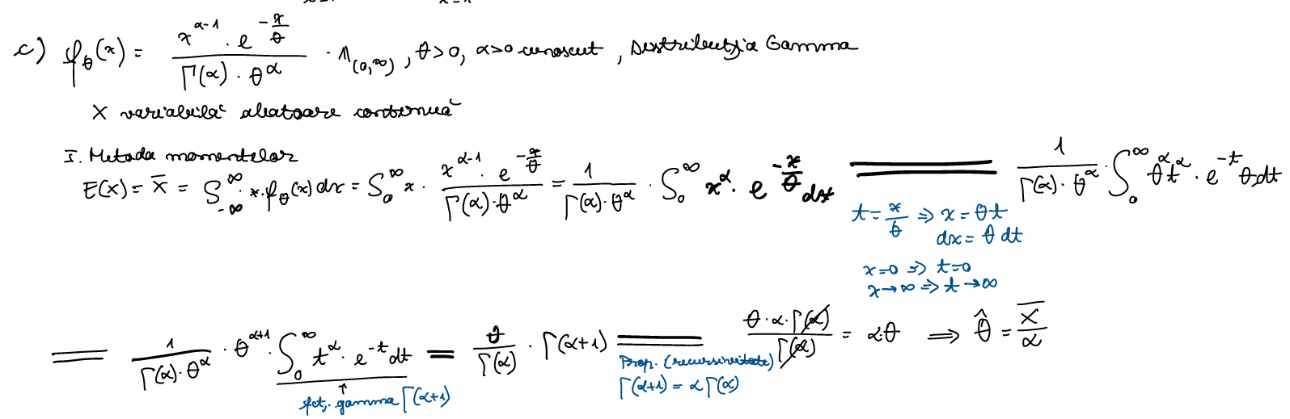

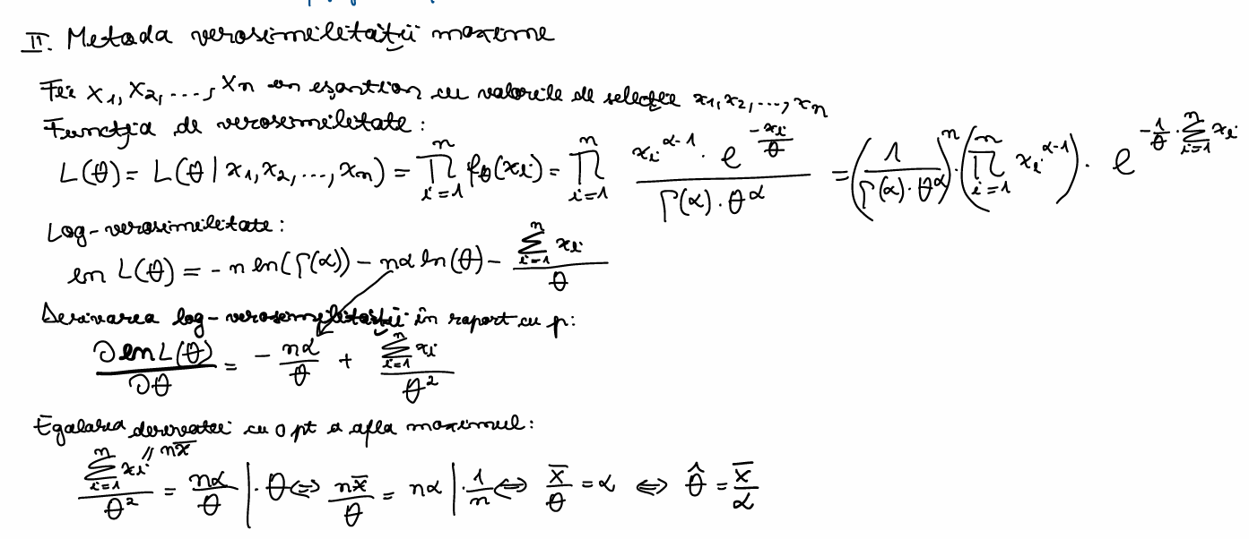

## c) f(teta)(x) = (x^(alfa-1)*e^(-x/teta))/(gamma(alfa)*teta^alfa), x nr din (0,infinit), teta > 0, alfa > 0 cunoscut

# esantionul care e de fapt un vector numeric (c combina valorile intr-un vector)

date_esantion <- c(6.269128, 25.204245, 13.994878, 13.391437, 11.458827, 10.565065, 11.706398, 10.625808,

7.485952, 16.353358, 9.277565, 8.566438, 14.788638, 6.830955, 9.542004, 20.272463,

36.562137, 12.244005, 16.084879, 11.454008, 15.592298, 6.332908, 13.106441, 6.198981,

15.726780, 7.883712, 35.124934, 11.856011, 13.766200, 16.534869, 16.803648, 11.196542,

19.785629, 26.300717, 21.270154, 7.192149, 5.882948, 15.812796, 10.963237, 24.963600,

13.802383, 15.281262, 10.310398, 20.940469, 23.992540, 15.869985, 12.041726, 12.521264,

10.869006, 15.386514, 14.636832, 18.104562, 17.029779, 4.506616, 20.941222, 12.050877,

9.757833, 20.070802, 12.472900, 6.474476, 15.059776, 13.157344, 9.124414, 13.768482,

24.354934, 12.363936, 11.110749, 9.092514, 17.856801, 14.757801, 13.898665, 9.119410,

11.430184, 11.958829, 13.516191, 10.701083, 14.713596, 10.121266, 16.945351, 13.524070,

14.742403, 19.165805, 10.338392, 12.327837, 19.619227, 7.328246, 14.894399, 19.631003,

7.622796, 12.343832, 13.138183, 10.061520, 17.674638, 9.675168, 12.115561, 15.182861,

13.292479, 17.888244, 16.695139, 2.952334)

alfa <- 7

## MM

x_bar <- mean(date_esantion) # media 1/n*(suma dupa i de la 1 la n din)xi

teta_estimat <- x_bar/alfa # formula determinata pentru functie folosind MM

## MVM

sum_x <- sum(date_esantion)

log_gamma_alfa <- log(lfactorial(alfa-1))

logVerosimilitate <- function(teta)

{

log_verosim <- (-length(date_esantion))*log_gamma_alfa-length(date_esantion)*alfa*log(teta)-sum_x/teta

return(log_verosim)

}

t <- seq(0.001, 0.5, by = 0.0001)

plot(t, sapply(t, logVerosimilitate), type = "l", col = "blue")

rez <- optimize(logVerosimilitate, interval = c(0.001,100), maximum = TRUE)

teta_mvm <- rez$maximum

cat("Estimarea lui teta folosind metoda momentelor:", teta_estimat,"\n")

cat("Estimarea lui teta folosind metoda verosimilitatii maxime:", teta_mvm,"\n")

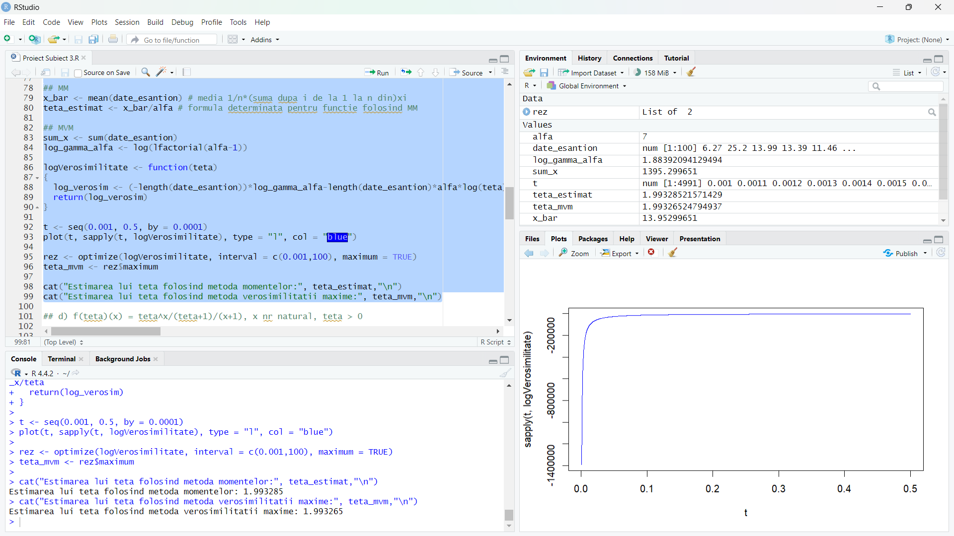

d)

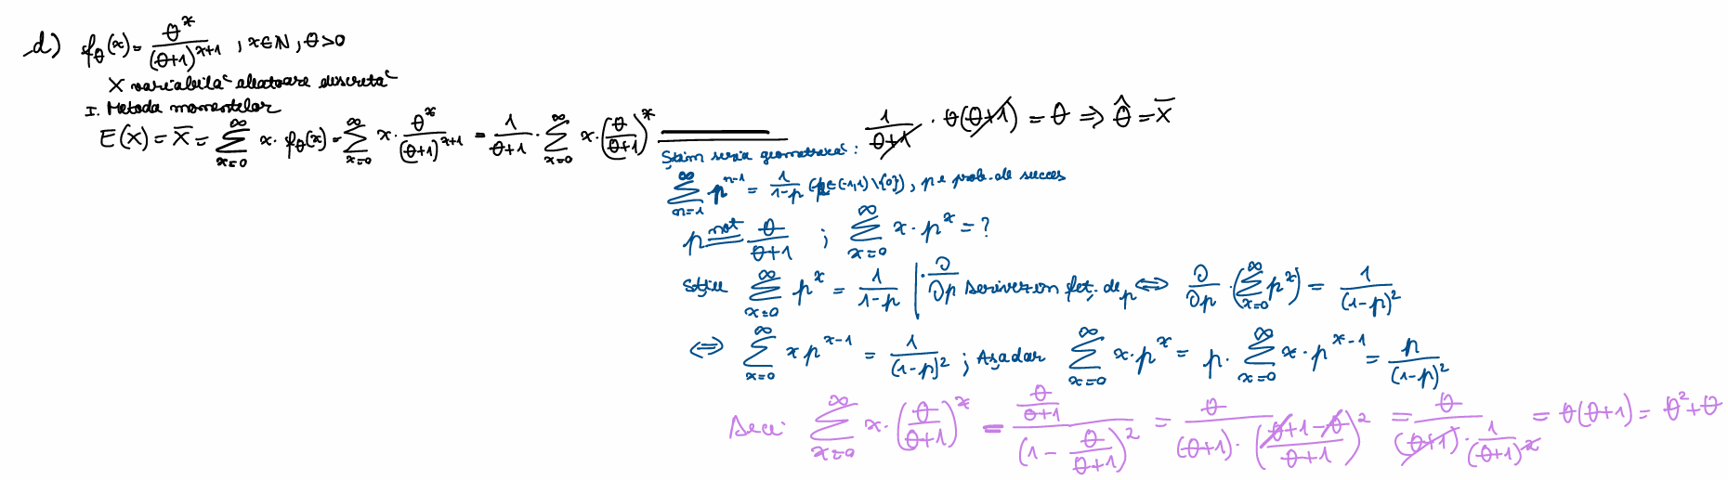

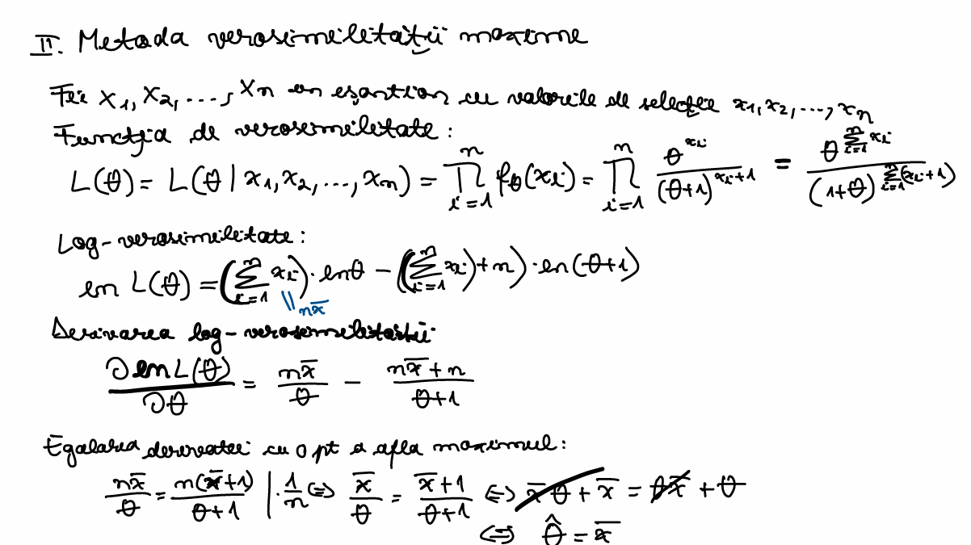

## d) f(teta)(x) = teta^x/(teta+1)/(x+1), x nr natural, teta > 0

# esantionul care e de fapt un vector numeric (c combina valorile intr-un vector)

date_esantion <- c(6, 3, 24, 24, 4, 56, 10, 13, 2, 28, 24, 2, 22, 11, 2, 8, 118, 2, 14, 19, 7, 9, 8, 189, 2, 9, 21, 6,

6, 2, 3, 2, 3, 18, 3, 2, 21, 1, 5, 9, 11, 13, 19, 76, 1, 5, 9, 4, 57, 1, 2, 16, 5, 2, 20, 8, 1,

40, 6, 4, 19, 6, 3, 2, 4, 9, 1, 5, 10, 12, 6, 525, 19, 6, 17, 2, 5, 159, 5, 62, 6, 3, 45, 21, 23,

3, 17, 2, 1, 1, 474, 15, 3, 3, 7, 7, 13, 4, 38, 4)

## MM

x_bar <- mean(date_esantion) # media 1/n*(suma dupa i de la 1 la n din)xi

teta_estimat <- x_bar # formula determinata pentru functie folosind MM

## MVM

sum_x <- sum(date_esantion)

logVerosimilitate <- function(teta)

{

log_verosim <- log(teta)*sum_x-log(teta+1)*(length(date_esantion)+sum_x)

return(log_verosim)

}

t <- seq(0.001, 0.5, by = 0.0001)

plot(t, sapply(t, logVerosimilitate), type = "l", col = "blue")

rez <- optimize(logVerosimilitate, interval = c(0.001,100), maximum = TRUE)

teta_mvm <- rez$maximum

cat("Estimarea lui teta folosind metoda momentelor:", teta_estimat,"\n")

cat("Estimarea lui teta folosind metoda verosimilitatii maxime:", teta_mvm,"\n")

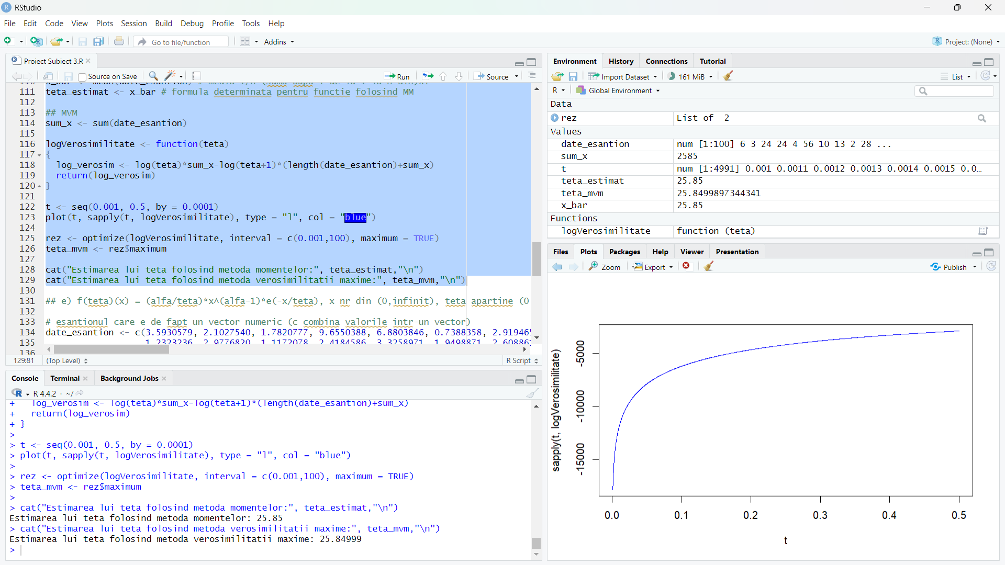

e)

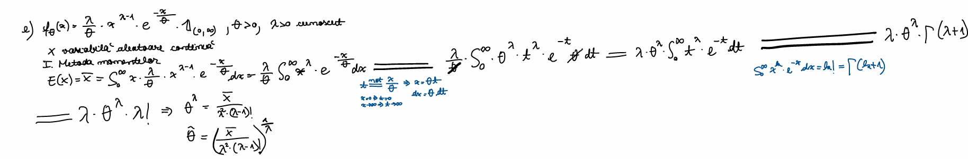

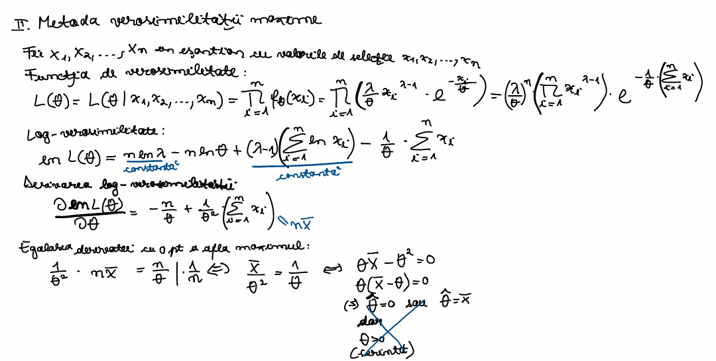

## e) f(teta)(x) = (alfa/teta)*x^(alfa-1)*e(-x/teta), x nr din (0,infinit), teta apartine (0,infinit), alfa apartine (0,infinit) fixat

# esantionul care e de fapt un vector numeric (c combina valorile intr-un vector)

date_esantion <- c(3.5930579, 2.1027540, 1.7820777, 9.6550388, 6.8803846, 0.7388358, 2.9194654, 3.1178660,

1.2323236, 2.9776820, 1.1172078, 2.4184586, 3.3258971, 1.9498871, 2.6088612, 3.9535062,

3.0389107, 4.4226628, 3.9366318, 2.4551569, 5.2814487, 5.6778622, 4.7683935, 1.1581498,

3.1270783, 4.1473311, 7.4830426, 1.1342893, 1.7773392, 7.7510826, 1.3919927, 2.3613291,

2.6234826, 1.6562602, 1.4992235, 2.3455062, 3.8458809, 5.8333841, 3.3834034, 1.5202546,

3.1248186, 5.3029567, 3.6225571, 4.8309931, 3.1579595, 3.2640258, 3.9538891, 4.0796841,

4.0991772, 3.2779944, 2.5002127, 3.0654695, 1.6996010, 3.2175175, 1.9033087, 4.4052061,

2.3158379, 2.4778345, 5.4382190, 4.9141207, 6.0978745, 1.1428936, 3.5639106, 7.4541937,

7.7778289, 3.2859563, 0.7432908, 1.4442696, 3.6619932, 2.8361371, 4.3180773, 1.6763585,

4.4464154, 2.5049617, 0.4448735, 5.0518839, 3.4151834, 1.6823650, 5.4517583, 2.8212788,

2.1566837, 2.9893287, 1.6925123, 6.5197938, 4.2165408, 1.6728425, 2.7650830, 2.6742755,

2.9622047, 0.7809781, 1.3913415, 5.3430751, 2.4859925, 3.7329465, 6.3129236, 0.6635228,

3.7640343, 2.1850174, 4.3773328, 5.0931544)

alfa <- 3

## MM

x_bar <- mean(date_esantion) # media 1/n*(suma dupa i de la 1 la n din)xi

# asta e singurul subpunct in care formula de la mm nu corespunde cu cea de la mvm

teta_estimat_mm <- (x_bar/(alfa^2*lfactorial(alfa-1)))^(1/alfa)

## MVM

sum_x <- sum(date_esantion)

sum_log_x <- sum(log(date_esantion))

logVerosimilitate <- function(teta)

{

log_verosim <- length(date_esantion)*log(alfa)-length(date_esantion)*log(teta)+(alfa-1)*sum_log_x-(1/teta)*sum(date_esantion)

return(log_verosim)

}

t <- seq(0.001, 0.5, by = 0.0001)

plot(t, sapply(t, logVerosimilitate), type = "l", col = "blue")

rez <- optimize(logVerosimilitate, interval = c(0.001,100), maximum = TRUE)

teta_mvm <- rez$maximum

teta_mvm_calc <- x_bar

cat("Estimarea lui teta folosind metoda momentelor:", teta_estimat_mm,"\n")

cat("Estimarea lui teta folosind metoda verosimilitatii maxime pe foaie:", teta_mvm_calc,"\n")

cat("Estimarea lui teta folosind metoda verosimilitatii maxime:", teta_mvm,"\n")

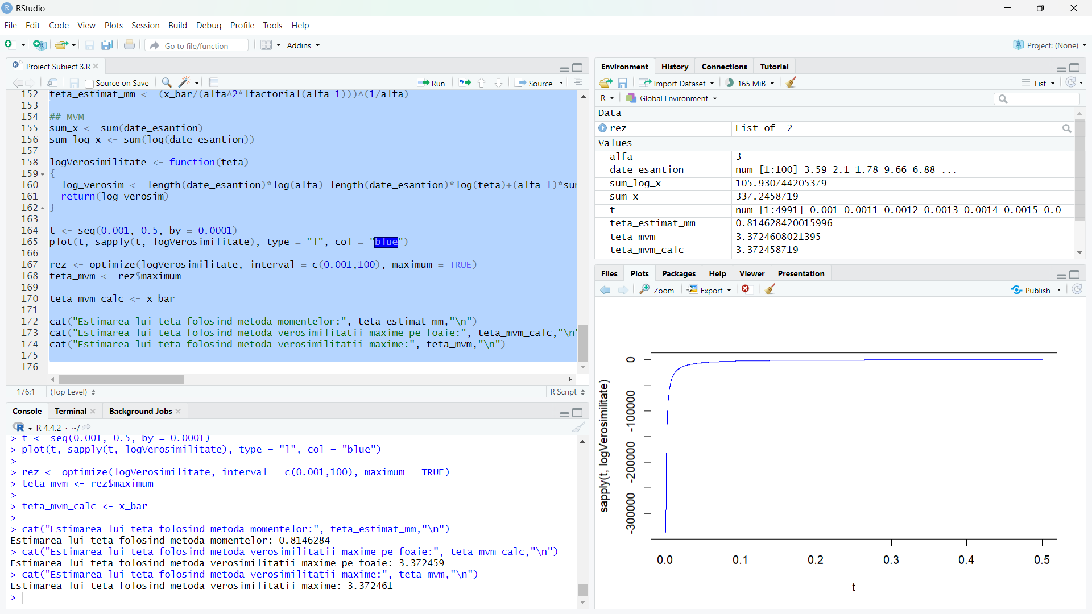

Dupa cum se poate observa pentru aceasta functie estimatorul teta da diferit in ambele metode, atat prin calcul direct, cat si la nivel de cod.